- Purpose
  - The purpose of this document is to describe the procedure for retrofitting a handle to the new trigger design on the high speeds, low speeds, Dual speeds, and Dust control machines.
- Scope
  - This SOP applies to all field retrofits. The process applies to the following machine ID’s:
E083010EQM0600BE1200 – Foreman 20DS Dual Speed Floor Machine 20”
E083010EQM0607BE1200 – Foreman 20DS Dual Speed Floor Machine 20”-Canada
E083013EQM0600BE1200 – Crewman 17HD Heavy Duty Floor Machine 17”
E083013EQM0607BE1200 – Crewman 17HD Heavy Duty Floor Machine 17”-Canada
E083014EQM0600BE1200 – Crewman 20HD Heavy Duty Floor Machine 20”
E083014EQM0607BE1200 – Crewman 20HD Heavy Duty Floor Machine 20”-Canada
E083015EQM0600BE1200 – Crewman 1600 RPM Cord-Electric Burnisher
E083015EQM0607BE1200 – Crewman 1600 RPM Cord-Electric Burnisher-Canada
E083016EQM0600BE1200 – Crewman 2000 RPM Cord-Electric Burnisher
E083016EQM0600BE1200 – Crewman 2000 RPM Cord-Electric Burnisher-Canada
E083018EQM0600BE1200 – Crewman DC2000 Cord Electric Dust Control Burnisher
E083018EQM0607BE1200 – Crewman DC2000 Cord Electric Dust Control Burnisher-Canadian
E085263EQM0600BE1200 – Crewman 20” Dust Control Battery Burnisher
E085812EQM0600BA1000 – Basic Dragon Dustless Floor Machine
E085812EQM0607BA1000 – Basic Dragon Dustless Floor Machine - Canadian
E083009EQM0600BE1200 – Foreman 17DS Dual Speed Floor Machine 17”
- Materials
  - The proper components for the retrofit are provided in the kit.
The following items are needed but not supplied:
-Silicone Grease
-Hand Drill with a phillips bit or a phillips screw driver
-Needle Nose pliers
-O-ring pick or equivalent (if available / works the best to install springs)
- Definitions

- Procedure
**Note – The photos below are taken from a Crewman machine. Depending on the machine model being retrofitted, the actual surrounding handle components seen in the photos may not reflect your machine. The parts relating to the retrofit and the steps to get there are the same no matter the model.
  - Locate the two pieces that make up the handle trigger assembly. These need to be dry fitted to verify that they function properly. Note the orientation in the photos below.
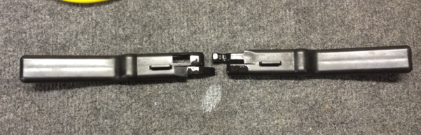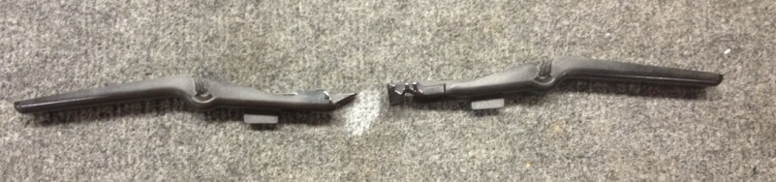
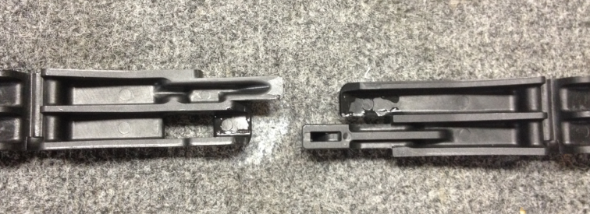
  - Interlock the two pieces as shown. This will require a slight scissor motion.
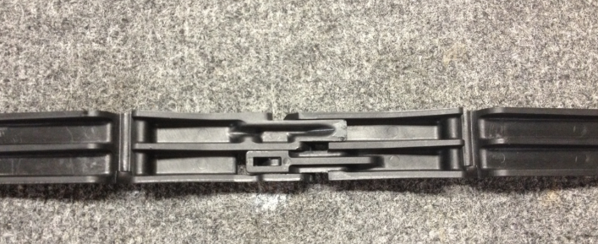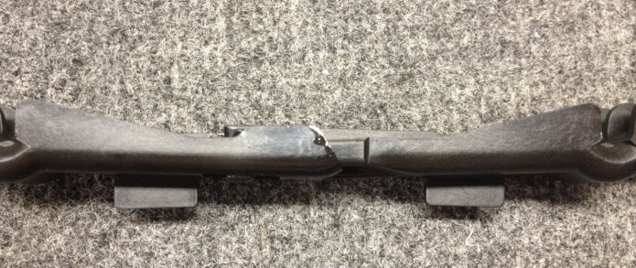
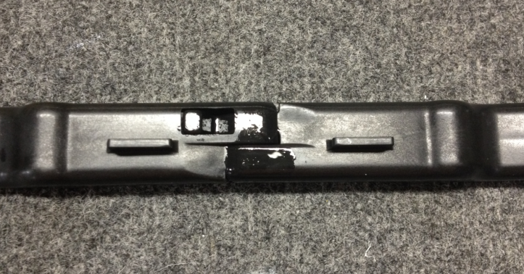

  - Rotate the two pieces up and down to make sure that they slide freely and without catching. If they catch, there are 2 things that can be done. Take a knife and remove any flashing from the top edges of the parts. Apply a very light coating of silicone grease onto the sliding surfaces. Once the pieces move properly, proceed to the retrofit.
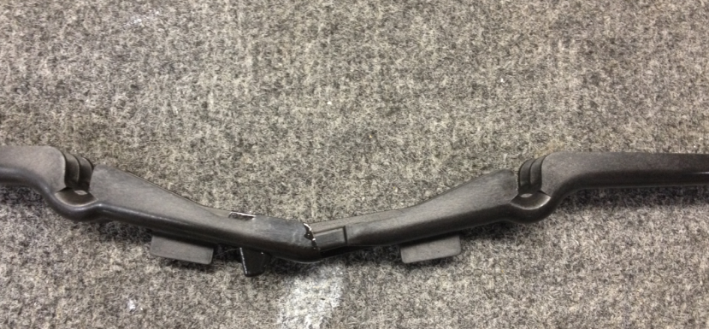
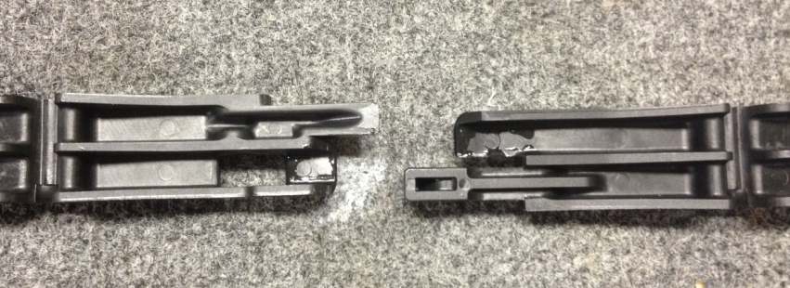
De-flash edges if needed
  - Remove the back cover from the machine handle. There are 4 screws holding it on.
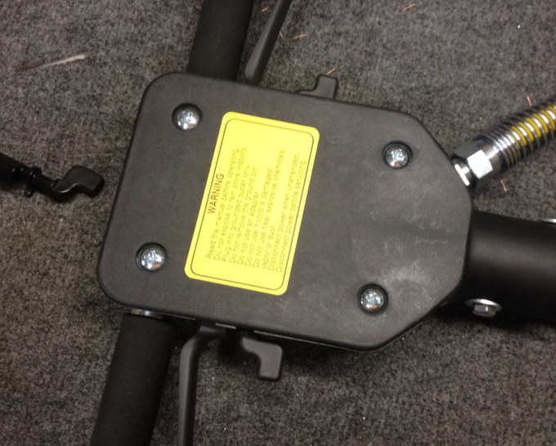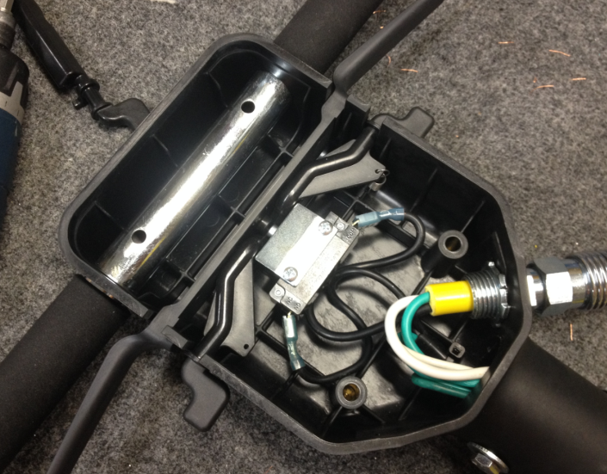

  - Remove the trigger switch. The metal switch plate will not be used and can be discarded. There is no need to disconnect the wires from the switch.
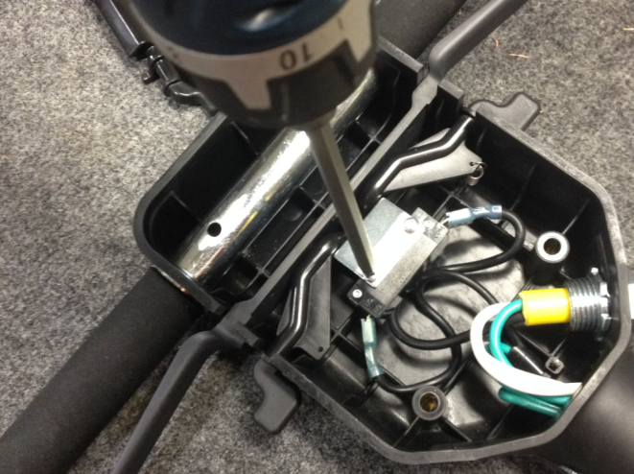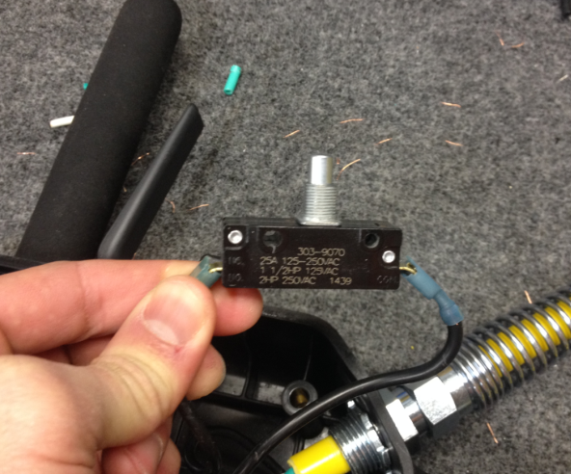
  - Use a pair of needle nose pliers to disconnect the spring from the safety lock.
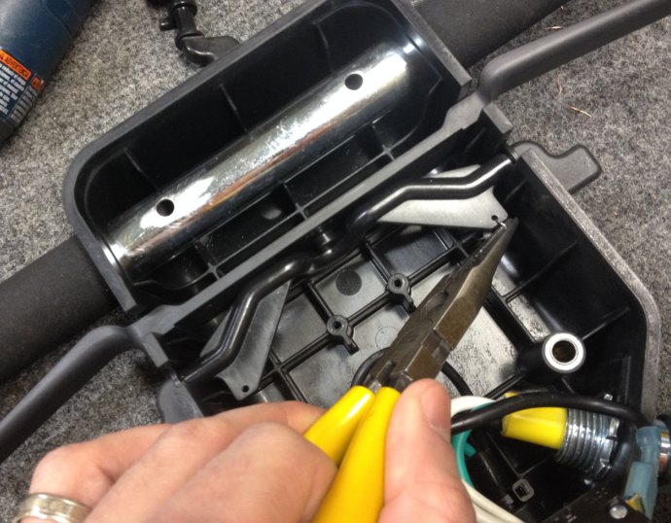
  - Remove the old safety lock and trigger.
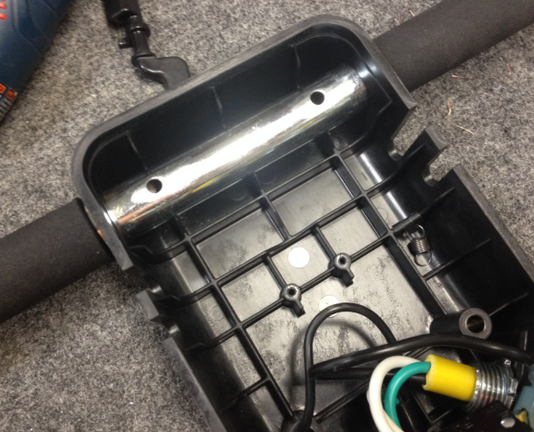
  - Leave the existing spring in place. A spare is provided in the kit in case the existing sprint is damaged. A good idea here is to take the pliers and smash down the tab on the clip that holds the spring against the rib. This will prevent the loop on the spring from falling off of the spring clip when there is no tension.
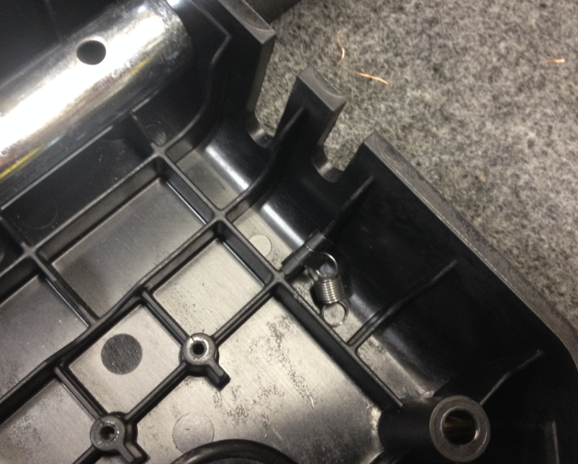
  - Take the 2nd spring from the kit and place the loop of it over the tab on the spring clip provided.
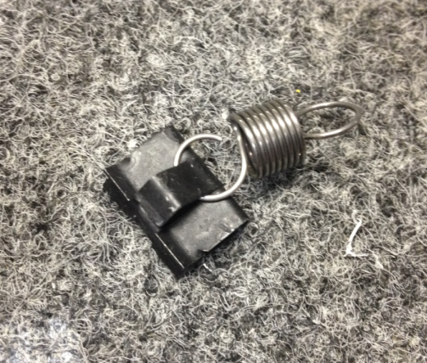
  - Use the pliers to smash down the tab so that the spring does not fall off.
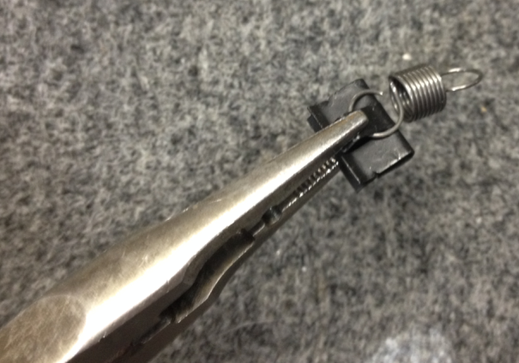
  - Install the 2nd spring into the handle on the rib shown. It will be in the same orientation as the existing spring. The clip presses onto the rib. Be sure the location is correct because the clips bite into the plastic and can’t be removed without destroying them.
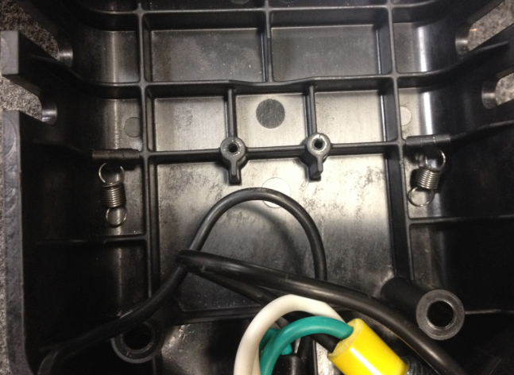
  - Take the conical spring provided and thread it onto the trigger switch. Simply twist it onto the threaded portion of the switch.
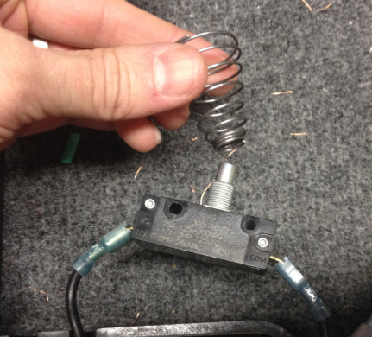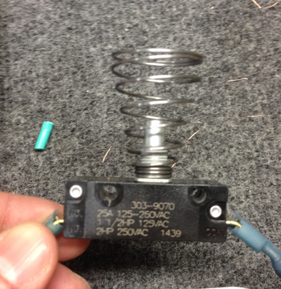
  - Re-install the trigger switch into the handle.
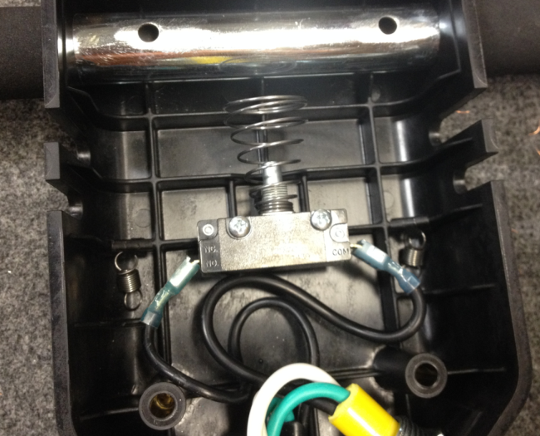
  - Install the new safety lock into the handle in the orientation shown. The sides of the handle mold may need to be pushed inwards to fit the piece.
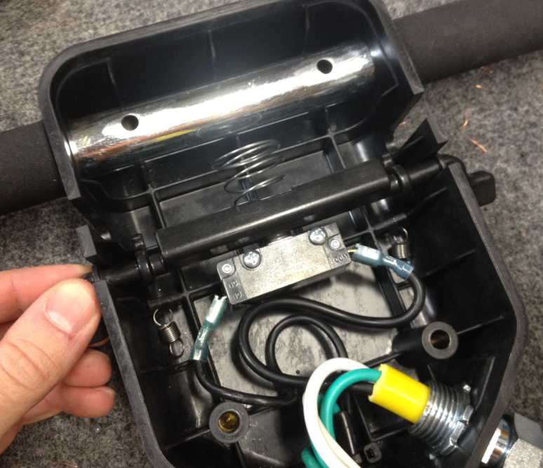
  - Each of the springs need to be stretched under the safety lock and around the finger shown. This is best done using an o-ring pick or equivalent. If none are available, needle nose pliers will need to be used.
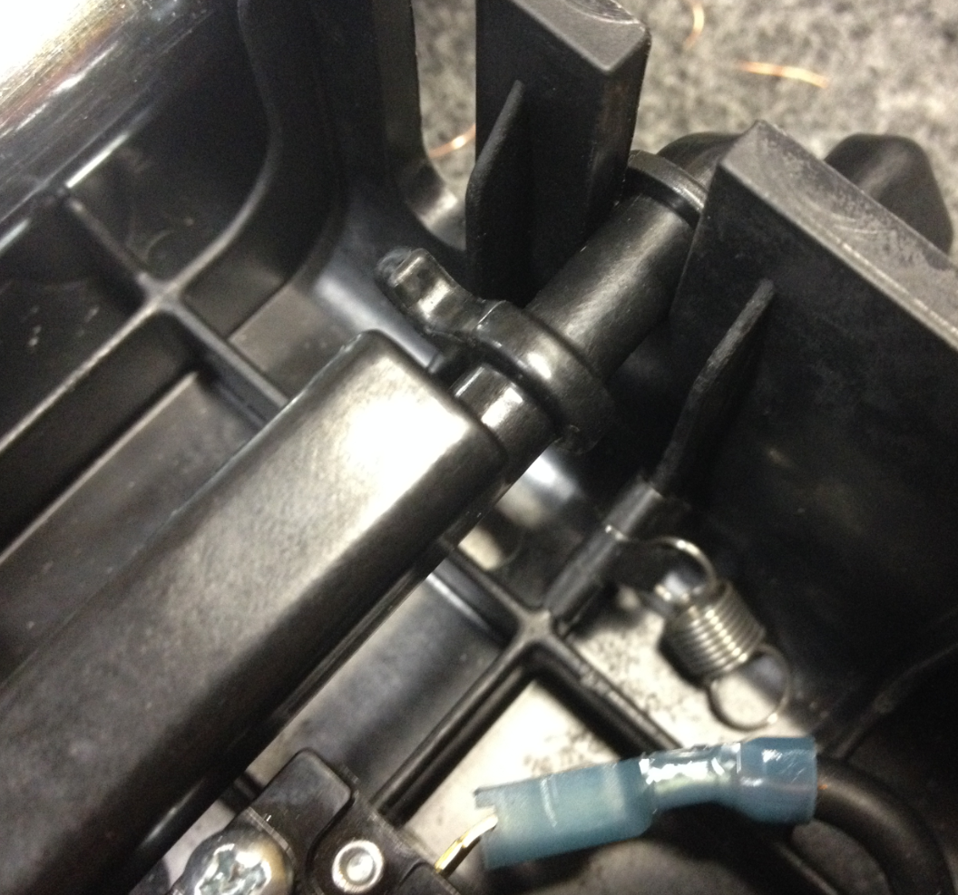
Spring will pass under the safety lock here
Spring will loop over this finger
  - Once the spring has been stretched over the rib and under the safety lock, rotate the finger of the safety lock downwards so that the loop on the spring can be placed over it. Rotating the finger down decreases the distance that the spring needs to be stretched and makes installation much easier.
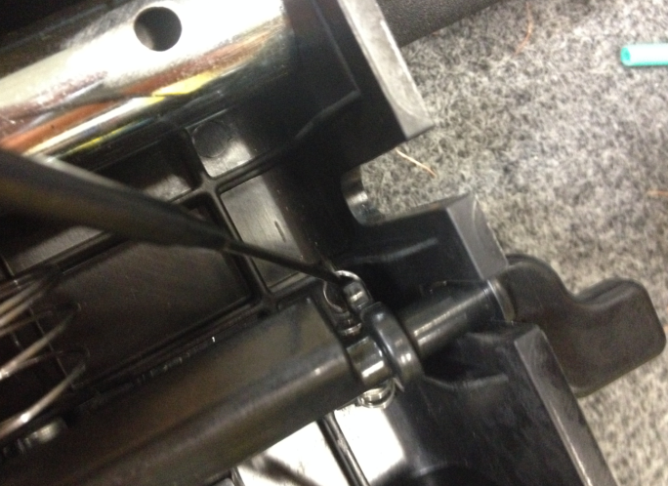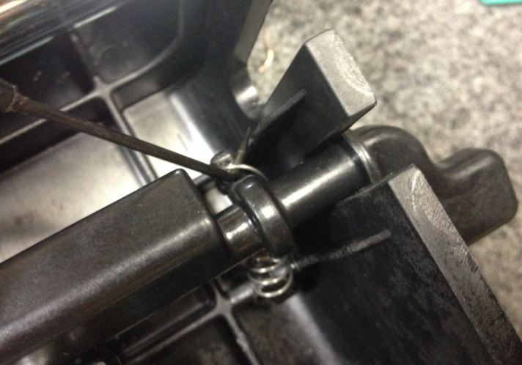
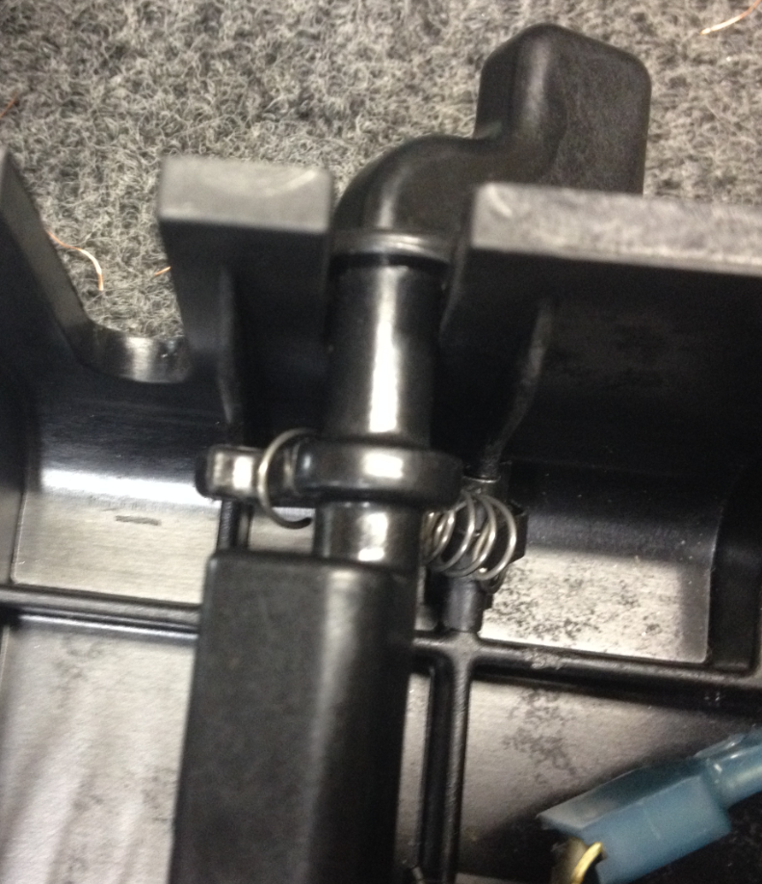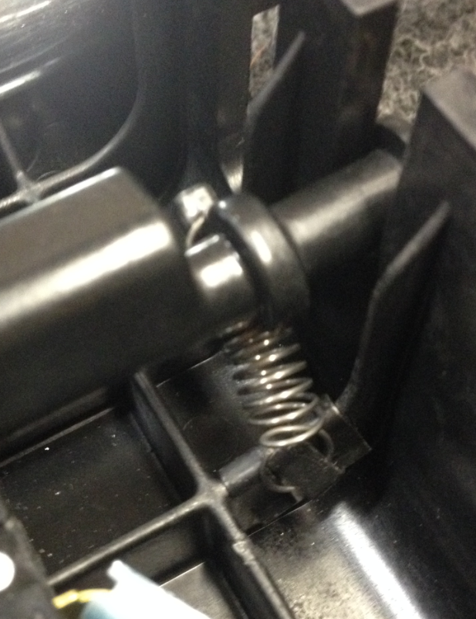
Spring passes under safety lock
  - For all remaing steps, please be sure that the safety lock is not allowed to rotate freely since there is spring pressure being applied. This will cause it to spin and the spring will pop off. There is no mechanical stop in place at this point to keep it from spinning. Keeping a finger on the safety lock will help keep it still.

  - Repeat the installation for the opposite spring. When rotating the safety lock so that the spring can be looped over the finger, use your other hand to make sure that the opposite spring does not come off.
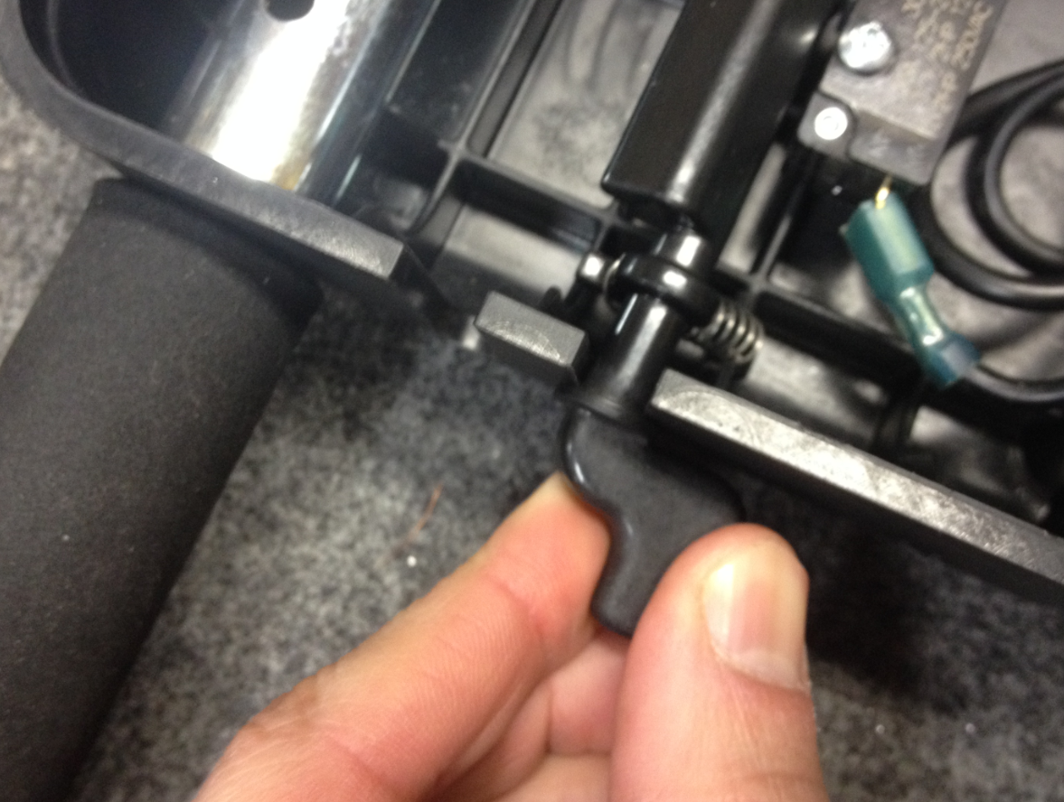
  - Take the 2 pieces of the trigger handle that were assembled first and orient them to the handle as shown.
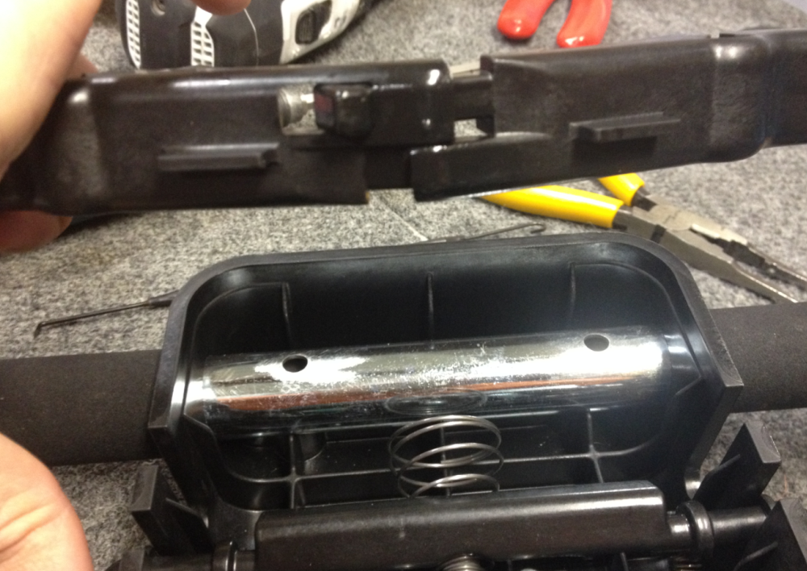

  - Use one finger to compress the conical spring on the switch and then slide the handle into the grooves. Remember to try to hold the safety lock steady.
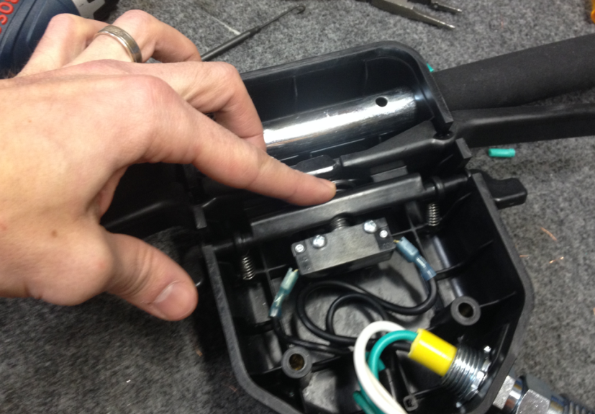
  - The assembled handle now looks like the following photo.
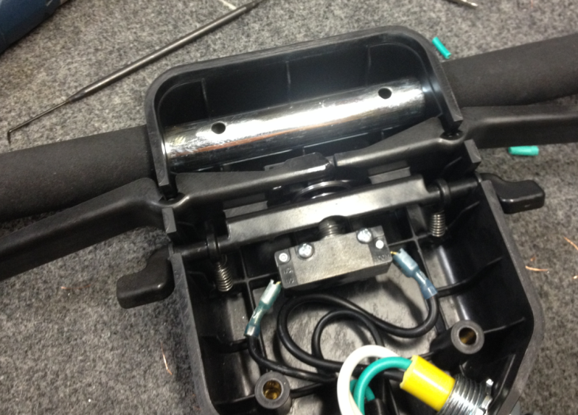
  - Replace the back cover of the handle. Assembly is now complete.
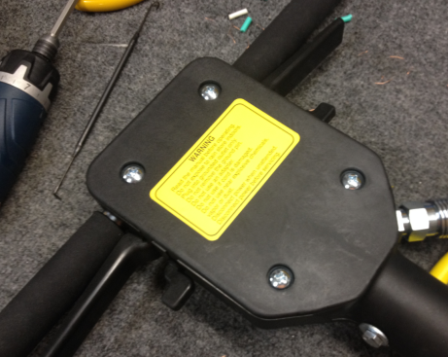
- References (optional section as needed)

- Training Guide

Functional Training Groups Requiring Training

- SOP Change Control

Date of Change | Reason for Change
11/22/2013 | This is the first version of the S.O.P. hence there are no revisions to this document.

Approvals

Submitter/Author Approval:__________________________________ Date:______________________

Management Approval:______________________________________ Date:______________________

QAU Approval:_____________________________________________ Date:______________________

